TOGETHER WE ARE STRONG
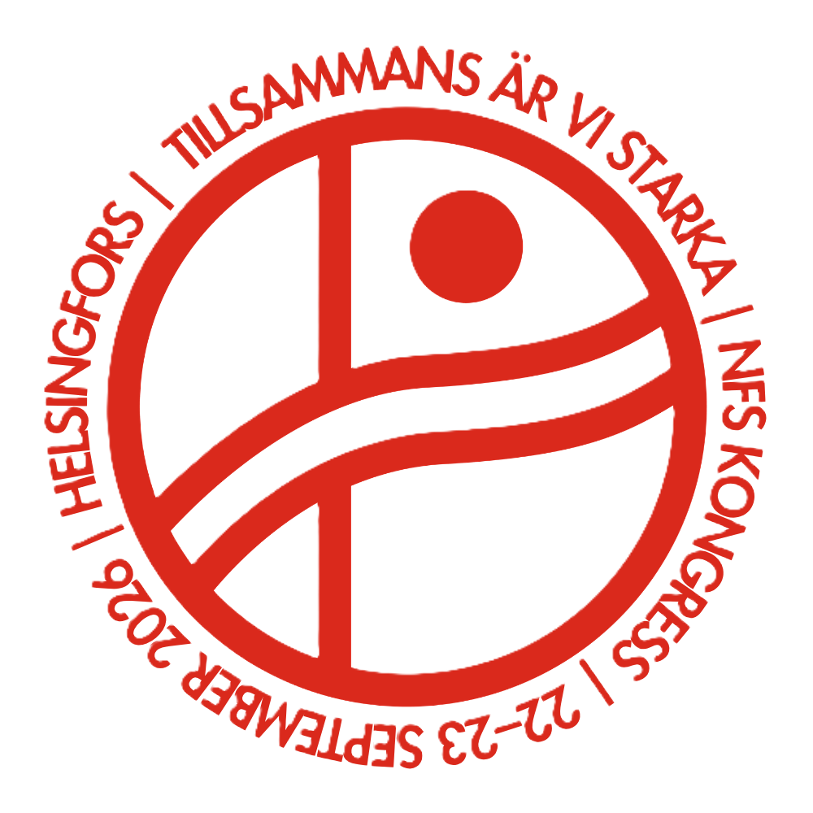

Trade Unions as the First Line of Defence
Nordic Trade Union Congress 2026 – NFS 5th congress
22–23 September 2026
Paasitorni, Helsinki

WELCOME TO THE NORDIC TRADE UNION CONGRESS
On 22–23 September, the Nordic trade union movement will gather in Helsinki for the fifth Nordic trade union congress. Over two days, we will meet under the theme “Together We Are Strong: The Trade Union as the First Line of Defence.”
The security landscape has changed fundamentally. War in our region, increasing geopolitical tensions, and new threats to our societies have made issues of security, preparedness, and resilience more important than ever. For the trade union movement, this is both about safeguarding workers and helping to ensure that our societies continue to function even when faced with major challenges and disruptions.
The Congress will take us from the geopolitical and security situation in the Nordic region and the Arctic, through the role of working life in Nordic preparedness, to the practical question: What do we do when a crisis strikes?
Through speeches, conversations, discussions, and collaborative work, we will learn from one another and explore how Nordic trade union cooperation can contribute to a safe and resilient Nordic region. A warm welcome!

Magnus Gissler
General Secretary, Council of Nordic Trade Unions (NFS)
TUESDAY 22 SEPTEMBER
11.30 Registration
12.00 Lunch
13.00 Congress opening
Magnus Gissler, General Secretary, NFS
Lóa Lava Brynjúlfsdóttir, Congress Host
NFS President Morten Skov Christiansen and the host country’s trade union representatives, Jarkko Eloranta and Else-Mai Kirvesniemi, will open the Congress together with the participants.
13.45 Opening perspective
How can we stand strong together in a time of growing uncertainty? Karen Ellemann will share her perspective on democratic development, preparedness, and the role of the Nordic region in a changing world. What threats and challenges does the Nordic region face, and how can we strengthen Nordic cooperation to address them together?
Karen Ellemann
Secretary General, Nordic Council of Ministers
Thematic Session 1: The Geopolitical and Security Situation in the Nordic Region and the Arctic
The security landscape in the Nordic region has changed fundamentally in recent years. Russia’s invasion of Ukraine, a more uncertain international environment, and increasing great-power competition in the Arctic are affecting our societies and labour markets. How does this development impact the trade union movement, what risks do we need to prepare for, and how can we contribute to security and stability in our region?
14.10 The Nordic Region in a New Geopolitical Context
Ann Linde, former Swedish Minister for Foreign Affairs and Nordic Cooperation, will provide an overview of the geopolitical situation and look ahead. Where does the Nordic region stand today? Which developments are affecting us, and where do we have the opportunity to influence outcomes ourselves?
Following the keynote address, the discussion will continue at the tables and through questions from participants.
14.45 Coffee break
15.15 When Democracy Is Challenged from Within
Polarisation and anti-democratic forces are challenging democracy and political cooperation, including in the Nordic region. How are our shared institutions and Nordic cooperation affected as divisions deepen? Eva Lindh will share her perspective on democratic resilience and how we can address threats that emerge from within.
Eva Lindh
Chair, Committee for Welfare in the Nordic Region, Nordic Council
15.25 Security in the Nordic Region and the Arctic
What are the foundations of security and resilience in the Nordic region? In an interactive discussion, different Nordic perspectives on security, geography, and cooperation will come together.
Leaders from the Nordic trade union movement will participate alongside Karen Ellemann, Secretary General of the Nordic Council of Ministers. The discussion will be followed by an ideas workshop in which participants will explore what the trade union movement can influence and identify the issues on which we need to cooperate in the future.
16.10 The European and Global Perspective
How does the changing geopolitical landscape affect the trade union movement in Europe and around the world? Esther Lynch and Cathy Feingold will provide European, American, and global perspectives on the challenges facing workers and trade unions. What does this development mean for international trade union cooperation, and how can we stand stronger together in an increasingly uncertain world?
Esther Lynch
General Secretary, European Trade Union Confederation (ETUC)
Cathy Feingold
International Director, American Federation of Labor and Congress of Industrial Organizations (AFL-CIO)
Afterwards, Ann Linde, Esther Lynch, and Cathy Feingold will come together for a discussion on the geopolitical situation and its implications for the Nordic region and the trade union movement.
17.05 Closing Reflections on the Day
A concluding perspective on the day will be provided by Antti Lindtman, Leader of the Social Democratic Party of Finland.
Antti Lindtman
Party leader, the Social Democratic Party of Finland
19.00 Mingle and dinner
Restaurant Meripaviljonki

WEDNESDAY 23 SEPTEMBER
09.00 Thematic Session 2: When Preparedness Becomes Part of Everyday Life
The Role of Working Life in a Resilient Nordic Region
The pandemic, the energy crisis, and the deteriorating security situation have demonstrated just how vulnerable our societies can be. As a result, issues such as supply security, preparedness, and critical societal functions have gained renewed importance. How are the Nordic countries addressing these challenges? What can we learn from one another’s experiences, and what role should the trade union movement play?
09.00 Kick-off and reflection
We will build on the perspectives and insights from the first day of the Congress and turn our attention to preparedness and resilience in working life.
09.10 From the Arctic to the Workplace: How Do We Build a Resilient Nordic Region?
What does it take for our societies to remain strong in a changing world? We will focus on the Arctic, societal resilience, and security of supply, while exploring the role that working life plays in building a resilient Nordic region.
Joel Linnainmäki
Researcher, Finnish Institute of International Affairs (FIIA)
09.30 Inspiration Session
What Are We Doing in the Nordic Countries?
How are the Nordic countries already working with preparedness and security of supply? Trade union representatives from across the Nordic region will share concrete examples of how the trade union movement and the social partners are working on preparedness and cooperation with other societal actors.
These experiences will serve as the starting point for participants’ own pathway discussions: How can working life strengthen preparedness and resilience for a safer and more resilient Nordic region?
10.30 Coffee break
11.00 A robust Europe
Emergency Preparedness, Resilience, and a Changing World of Work
Preparedness is not only a national or Nordic issue. What role do the social partners play at the European level? How can we ensure both endurance and flexibility during crises while safeguarding workers’ rights and maintaining good working conditions?
Claes-Mikael Ståhl
Deputy General Secretary, European Trade Union Confederation (ETUC)
Ilkka Oksala
Director, Confederation of Finnish Industries (EK)
The discussion will continue with questions and dialogue with participants, followed by a panel in which trade union leaders from across the Nordic region will share their perspectives on preparedness, cooperation, and the role of working life in building resilience.
12.00 Lunch
13.00 Thematic Session 3: When Crisis Strikes – What Do We Do?
When society faces crises, both institutions and cooperation are put to the test. The trade union movement plays a vital role in protecting workers, maintaining essential societal functions, and contributing to solutions in challenging situations. How can we strengthen our preparedness, what priorities do we need to make, and what is required of us when Nordic cooperation is put to the test?
13.05 The Role of the Trade Union Movement When Crisis Strikes
Morten Skov Christiansen
President, NFS and the Danish Trade Union Confederation (FH)
What can the trade union movement do in practical terms when a crisis occurs? A Danish and Nordic perspective on responsibility, cooperation, and preparedness.
13.15 Nordic Experiences
What have we already learned from previous crises? We will explore concrete examples from the Nordic countries of how trade unions have worked with preparedness and security of supply.
These experiences will be followed by roundtable discussions on solutions and priorities. Participants will discuss what needs to be in place before the next crisis occurs, what the trade union movement should prioritize, and which issues we need to advance together.
14.20 Coffee break
14.40 When Nordic Cooperation Is Put to the Test – What Is Required of Us?
What does it take for Nordic cooperation to function effectively when our countries are faced with major challenges and disruptions? Johan Strang will place the Congress discussions in a broader perspective and look ahead to the opportunities for deeper Nordic cooperation.
Johan Strang
Professor, University of Helsinki
15.10 The Nordic Region and the Baltics in an Uncertain Time
How can we strengthen our societies and our cooperation in a time of increasing geopolitical uncertainty? Inga Ruginienė will provide a Baltic perspective on security, the role of the trade union movement, and the importance of close cooperation between the Nordic and Baltic countries. Drawing on her experience from Lithuania, she will look ahead to how we can work together to build stronger and more resilient societies.
Inga Ruginienė
Minister of Social Security and Labour, Lithuania; former Prime Minister and former president of the Lithuanian trade union confederation (LPSK)
15.30 A Nordic Outlook – Setting the Course Together
The presidents of NFS member organisations will gather on stage for the Congress’s closing reflection. What are the key takeaways from our days in Helsinki? Which issues do we need to continue working on, and how can we together strengthen the influence of the Nordic trade union voice?
15.50 Closing remarks
16.00 Mingle

SPEAKERS
Morten Skov Christiansen is President of the Danish Trade Union Confederation (FH) and President of NFS, with a long background in the Danish trade union movement.
Jarkko Eloranta is President of the Central Organisation of Finnish Trade Unions (SAK) and has a long background in the Finnish trade union movement.
Else-Mai Kirvesniemi is President of the Finnish trade union confederation STTK and has extensive experience in the Finnish trade union movement.
Karen Ellemann is Secretary General of the Nordic Council of Ministers and a former Danish minister with responsibility for, among other areas, Nordic cooperation.
Ann Linde is Sweden’s former Minister for Foreign Affairs and has also served as Minister for EU Affairs, Trade and Nordic Cooperation.
Eva Lindh is a Member of the Swedish Parliament and the Nordic Council, where she chairs the Committee for Welfare in the Nordic Region.
Esther Lynch is General Secretary of the European Trade Union Confederation (ETUC) and has extensive trade union experience at Irish, European and international level.
Cathy Feingold is International Director of the AFL-CIO and Deputy President of the ITUC, with more than 25 years of experience in international trade union work.
Antti Lindtman is Chair of the Social Democratic Party of Finland and a Member of the Finnish Parliament, with a background in the trade union movement.
Joel Linnainmäki is a Research Fellow at the Finnish Institute of International Affairs (FIIA), specialising in Finland and security in Northern Europe.
Ilkka Oksala is the director of Work and Social Affairs Department at the Confederation of Finnish Industries (EK).
Claes-Mikael Ståhl is Deputy General Secretary of the European Trade Union Confederation (ETUC), responsible for social dialogue, trade and standardisation.
Johan Strang is Professor of Nordic Studies at the University of Helsinki, specialising in Nordic political history, cooperation and democracy.
Inga Ruginienė is Lithuania’s Minister of Social Security and Labour and former Prime Minister, with a long background in the trade union movement.
Magnus Gissler is General Secretary of NFS and works to strengthen Nordic trade union cooperation at Nordic and international level.
Lóa Lava Brynjúlfsdóttir is the Congress host, a former General Secretary of NFS and an experienced lecturer and organisational development professional.

